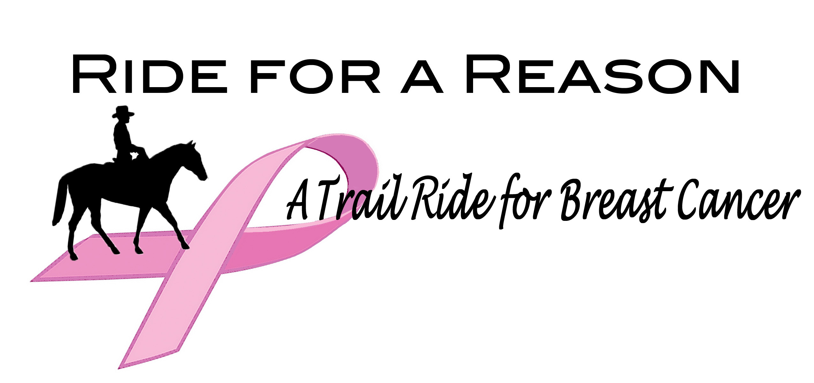

SATURDAY, October 3, 2026 (Rain date SUNDAY, October 4th)
Patten Brook Farm/ Jen & George Tuthill
420 Washburn Rd.
Alexandria, NH 03222

Fee $45.00
Held with the deepest appreciation of ACS

NAME OF RIDER_______________________HORSE Name______________ Email______________________

Phone #1_______________________ Phone #2_________________

Mailing Address: ____________________________________________________________________

Riders and Drivers Are Welcome: Riding trails will entail 7+ miles or 10+ miles through woodlands streams and fields.
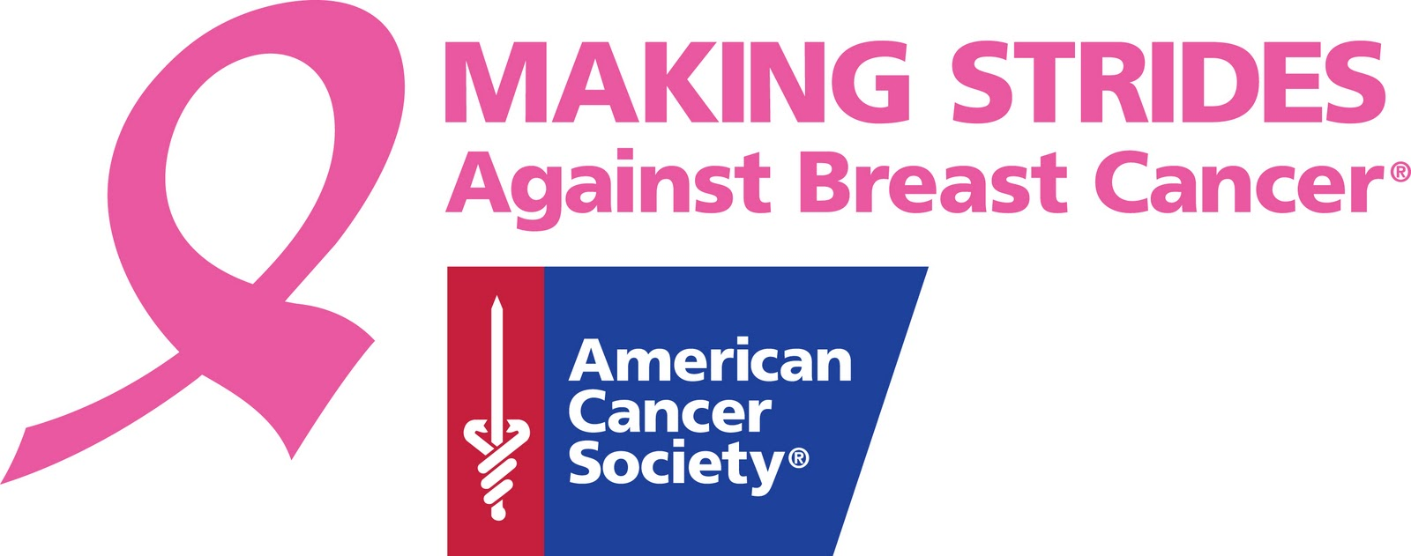
All Proceeds will benefit the ACS Making Strides Against Breast Cancer
Donate directly to our Making Strides Team: Ride4Reason through the website:
http://main.acsevents.org/goto/Ride4Reason.
Or
Make a check payable to: American Cancer Society (ACS)
and mail check and form to: Ride4Reason registration Carolyn Beard
PO box 53
Holderness NH 03245

Contact info: 603 968-2127 ‬ rte175horse@gmail.com
or
603-387-2794 email: jmeloney@icloud.com

If Possible: All Snail Mail and Online Entries should be received by September 26, 2025, for food head count planning. For more information go to: Http://www.ride4reasonNH.com

WAIVER OF LIABILITY
Warning: Under New Hampshire Law, an equine professional is not liable for an injury to or death of, a participant, in equine activities resulting from inherent risk of equine activities. Pursuant to N.H. Rev. Stat. 508:19
Every entry at a recognized trail ride or club activity shall constitute an agreement that the person making it, and the horse, shall be subject to the proper trail etiquette as is posted in NHH&TA. It shall further constitute that every horse and rider as entered, and that the owner and his/her rider agree to hold harmless “the ride”, the organizer/ manager, team assistants, property owners, coordinators for any action taken.
I, my party, and my heirs, further agree that if any damage is occasioned by, or injury or loss occur to myself or the horse entered, or to any vehicle or other article or possession that I may send with such horse, that I will make no claims, either now or forever thereafter. I further agree to indemnify, forever, the ride or barn activity, the committee, and any other property/landowners and any participants in the event against all claims, demands, suits, loss or damage to any property or person caused by myself, my horse, my attendants or my vehicle.
I understand that trail riding can involve being in remote areas for extended periods of time, far from communications, transportation, and medical facilities; and that these areas may have many natural hazards which ride management cannot anticipate, identify, modify, or eliminate; that horses can be excitable, difficult to control, and unpredictable; and that accidents can happen to anyone at any time.
Equine Clubs, associations and ride managers putting on organized rides cannot guarantee my safety or immunity from transmittable infections. With full appreciation of these facts, I voluntarily agree to participate in the ride and I knowingly and voluntarily:

• assume all risks associated with my participation at the ride, including but not limited to, the
risk of illness, death, bodily injury, disability, or exposure of transmittable infections.
• waive and release organizers, the manager of the ride, all ride volunteers, agents, and attendees
from all present and future claims of any type for any harm or loss, including but not limited to,
economic loss, personal injury, disease, death, or property damage suffered by me as a result of
my participation at the ride;

• agree to indemnify, hold harmless, and covenant not to sue organizers, the manager of the ride, all
ride volunteers, agents, and attendees for any personal injury, death, medical expenses,
disability, loss of capacity, property damage, court costs, attorney’s fees, or other loss arising
out of my participation at a ride.

By my signature below, I certify that have read and fully understand this Assumption of the Risk and
Waiver of Liability (Agreement) and understand that it affects my legal rights. I understand and
acknowledge that this Agreement shall be binding on me, my heirs, family, estate, representatives, and
assigns. If I am signing on behalf of a minor child, I fully intend that all such waivers be fully applicable
to said child and I assume the risk of said child participating at the Ride.

Signature of Rider___________________________________________ Date:____________________
Printed Name of Rider: ________________________

Signature of Minor Parent/Guardian: ____________________________Date:__________________

Printed Name of Minor Parent/Guardian: __________________________

It is required that Riders wear approved ASTM headgear, and have necessary medical emergency medications on person. (EPI Pens)

Online or mailed registration is preferred.

FOR ALL RIDERS (This information could be of help in an emergency.)
List Allergies: _________________________________________________________________________
Other Pertinent Information______________________________________________________________
Regular Doctor & Phone_________________________________________________________________
Insurance Carrier_______________________________________________________________________
Name and Phone # of nearest relative ______________________________________________________

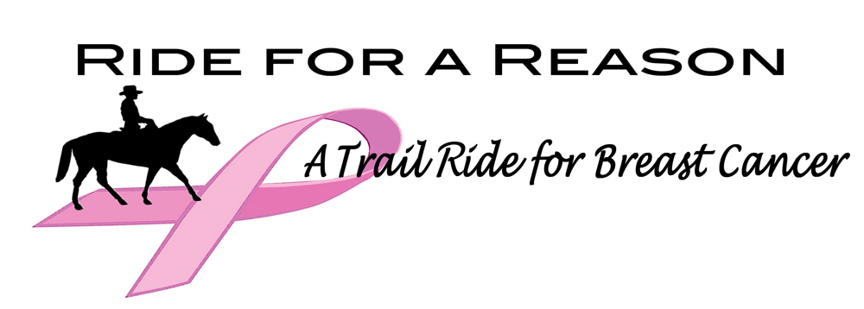
Directions:

Patten Brook Farm/ Jen & George Tuthill
420 Washburn Rd.
Alexandria, NH 03222

Concord & South
New Hampshire
Get on I-93

Follow I-93 to exit 23 from I-93 - NH-104 W/NH-132 S/State Hwy 104 W/State Hwy 132 S in New Hampton. (26 min - 30.6 mi from Loudon Rd)

Use the left lane and turn L onto State Hwy 132 S/State Hwy 104 W toward New Hampton/Bristol. Continue onto NH-104 W 4.9 mi. at light stay straight onto Lake St (N3A) 0.4 mi Turn left onto Bristol Hill Rd (Look for Cardigan Country Store )travel 1.1 mi bear left onto Plummer Hill Rd 0.8 mi. Turn left onto Thissell Rd 0.4 mi (directional sign will indicate), cross bridge bearing R at bottom of hill, onto Town Pound Rd, at stop sign stay straight onto Washburn Rd. continue .75 miles on Washburn, the farm will be on your right, the parking field on the L.

Alternative: at lights and junction of 104 and 132 in Bristol turn left onto 104 and follow until junction of Cass Mill Rd. turn right on Cass Mill, follow until junction with Washburn. Turn R onto Washburn, field on right for parking, farm on left.

